Practical 2

Part A:
Aim:
1. Smart thermostat (Thermostat.java, main in this file)
(a) Create class Thermostat with private String location, private int temperature, private static final int MIN=16 and MAX=30, and private static int activeCount=0. (b) Constructor(location, startTemp): store location; set temperature to startTemp if it is within MIN..MAX else 22; increment activeCount.
- Constructor(location): chain with this(location, 22).
- raise(): if temperature < MAX add 1, else print “Already at maximum
(30)”.
- lower(): if temperature > MIN subtract 1, else print “Already at minimum (16)”.
- Add getTemperature() (no setter) and static getActiveCount().
- In main: create two thermostats, call raise() 10 times then lower() 20 times in loops
(printing the temperature each time), then print getActiveCount().
Expected output: temperature rises to 30 then “Already at maximum”, falls to
16 then “Already at minimum”, count 2.

Code:
public class Thermostat {

// Instance variables private String location; private int temperature;

// Constants private static final int MIN = 16; private static final int MAX = 30;

// Static variable private static int activeCount = 0;

// Constructor with location and starting temperature public Thermostat(String location, int startTemp) { this.location = location;
if (startTemp >= MIN && startTemp <= MAX) { this.temperature = startTemp;
} else { this.temperature = 22;
}
activeCount++;
}

// Constructor with only location public Thermostat(String location) { this(location, 22);
}

// Increase temperature

public void raise() { if (temperature < MAX) { temperature++;
} else {
System.out.println("Already at maximum (30)");
}
}

// Decrease temperature public void lower() { if (temperature > MIN) { temperature--;
} else {
System.out.println("Already at minimum (16)");
}
}

// Getter for temperature public int getTemperature() { return temperature;
}

// Static getter for active thermostat count public static int getActiveCount() { return activeCount;
}

// Main method public static void main(String[] args) {

Thermostat t1 = new Thermostat("Living Room", 24);
Thermostat t2 = new Thermostat("Bedroom");

System.out.println("Initial Temperature of Living Room:
" + t1.getTemperature());
System.out.println("\nRaising temperature 10 times:"); for (int i = 1; i <= 10; i++) {
t1.raise();
System.out.println("Temperature: " + t1.getTemperature());
}

System.out.println("\nLowering temperature 20 times:"); for (int i = 1; i <= 20; i++) {
t1.lower();
System.out.println("Temperature: " + t1.getTemperature());
}

System.out.println("\nTotal Active Thermostats: " +
Thermostat.getActiveCount());
} }

Output:
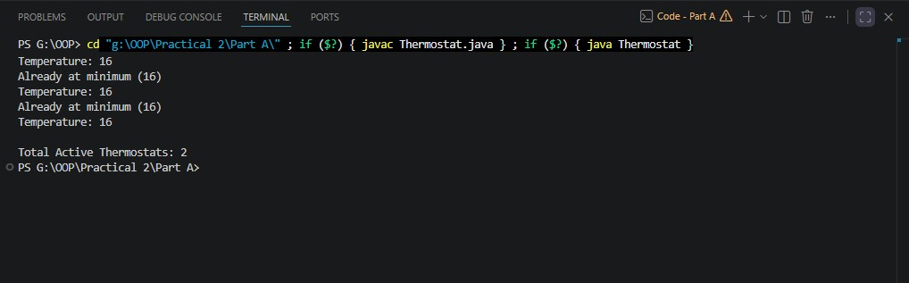

Aim:
2. Cinema show (CinemaShow.java, main in this file)
- Create class CinemaShow with private String title, private int seatsAvailable, private final int capacity, and private static int totalBooked=0.
- Constructor(title, capacity): set both and seatsAvailable = capacity. Constructor(title): chain with this(title, 100).
- book(int n): if n ≤ seatsAvailable, reduce seatsAvailable by n, add n to totalBooked, return true; else return false unchanged.
- cancel(int n): increase seatsAvailable by n but never above capacity.
- Add getSeatsAvailable() and static getTotalBooked().
- In main: run a sequence of book and cancel calls, printing the result and seats after each, then print getTotalBooked().
Expected output: booking more than available prints false and leaves seats unchanged; totalBooked equals the successful bookings.

Code:
public class CinemaShow {

// Instance variables private String title; private int seatsAvailable; private final int capacity;

// Static variable private static int totalBooked = 0;

// Constructor with title and capacity public CinemaShow(String title, int capacity) { this.title = title; this.capacity = capacity; this.seatsAvailable = capacity;
}

// Constructor with only title public CinemaShow(String title) { this(title, 100);
}

// Book seats public boolean book(int n) { if (n <= seatsAvailable) { seatsAvailable -= n; totalBooked += n; return true;
} else {
return false;
}
}

// Cancel seats public void cancel(int n) { seatsAvailable += n;
if (seatsAvailable > capacity) { seatsAvailable = capacity;
}
}

// Getter for available seats public int getSeatsAvailable() { return seatsAvailable;
}

// Static getter for total booked seats public static int getTotalBooked() { return totalBooked;
}

// Main method public static void main(String[] args) {

CinemaShow show = new CinemaShow("Avengers", 50);
System.out.println("Movie: Avengers"); System.out.println("Initial Seats: " + show.getSeatsAvailable());

System.out.println("\nBook 20 seats:"); System.out.println("Booking Successful: " + show.book(20));
System.out.println("Seats Available: " + show.getSeatsAvailable());

System.out.println("\nBook 15 seats:");
System.out.println("Booking Successful: " + show.book(15));
System.out.println("Seats Available: " + show.getSeatsAvailable());

System.out.println("\nBook 20 seats:"); System.out.println("Booking Successful: " + show.book(20));
System.out.println("Seats Available: " + show.getSeatsAvailable());

System.out.println("\nCancel 10 seats:"); show.cancel(10);
System.out.println("Seats Available: " + show.getSeatsAvailable());

System.out.println("\nBook 12 seats:"); System.out.println("Booking Successful: " + show.book(12));
System.out.println("Seats Available: " + show.getSeatsAvailable());

System.out.println("\nTotal Successfully Booked Seats:
" + CinemaShow.getTotalBooked());
} }

Output:
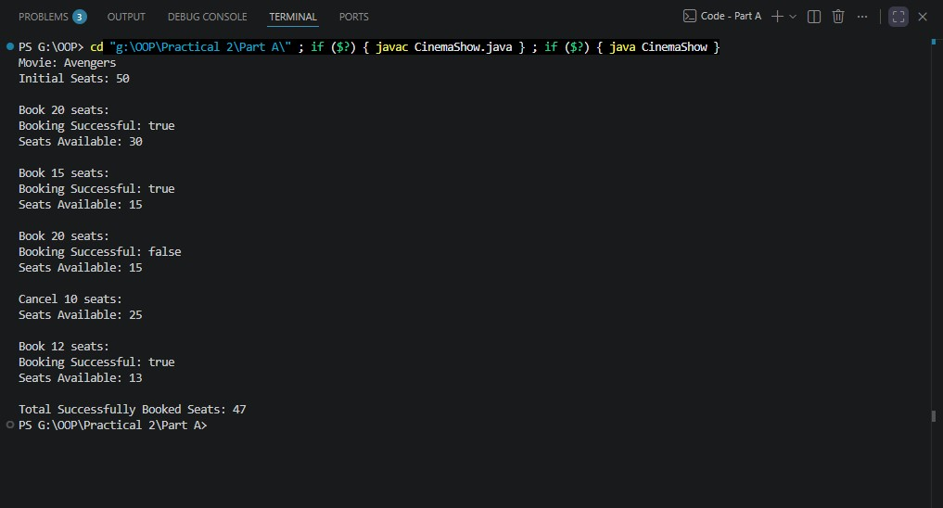

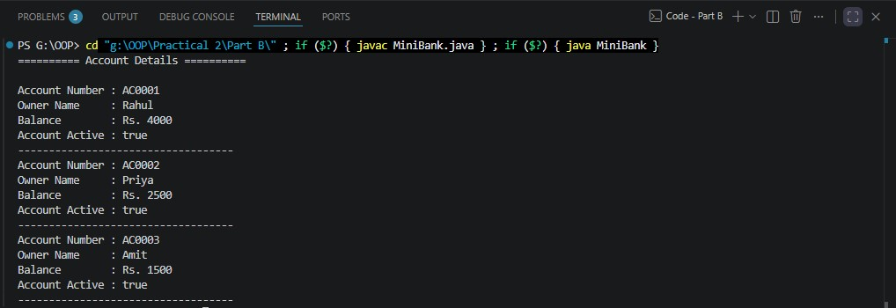

3. (For Advanced Learners – home) Parking lot (ParkingLot.java)
(a) Create class ParkingLot with private int twoWheelers and fourWheelers, private final int twoCap and fourCap, and private static long revenue=0.
(b) park(String type): for “two”, if twoWheelers < twoCap increment and add 20 to revenue; for “four”, if fourWheelers < fourCap increment and add 40; otherwise print “Full” and reject.
(c) leave(String type): decrement the matching count but never below 0.
(d) In main: simulate a sequence of park/leave events, printing each outcome, then print final occupancy and revenue.
Expected output: parking into a full section is refused; revenue = 20×(two parked) + 40×(four parked).

Code:
ParkingLot.java
public class ParkingLot {

// Current occupancy
private int twoWheelers;
private int fourWheelers;

// Maximum capacity
private final int twoCap;
private final int fourCap;

// Total revenue
private static long revenue = 0;

// Constructor
public ParkingLot(int twoCap, int fourCap) {
this.twoCap = twoCap;
this.fourCap = fourCap;
this.twoWheelers = 0;
this.fourWheelers = 0;
}

// Park a vehicle
public void park(String type) {

if (type.equalsIgnoreCase("two")) {

if (twoWheelers < twoCap) {
twoWheelers++;
revenue += 20;
System.out.println("Two-wheeler parked successfully.");
} else {
System.out.println("Full");
}

} else if (type.equalsIgnoreCase("four")) {

if (fourWheelers < fourCap) {
fourWheelers++;
revenue += 40;
System.out.println("Four-wheeler parked successfully.");
} else {
System.out.println("Full");
}

} else {
System.out.println("Invalid vehicle type.");
}
}

// Vehicle leaves
public void leave(String type) {

if (type.equalsIgnoreCase("two")) {

if (twoWheelers > 0) {
twoWheelers--;
System.out.println("Two-wheeler left.");
} else {
System.out.println("No two-wheeler to leave.");
}

} else if (type.equalsIgnoreCase("four")) {

if (fourWheelers > 0) {
fourWheelers--;
System.out.println("Four-wheeler left.");
} else {
System.out.println("No four-wheeler to leave.");
}

} else {
System.out.println("Invalid vehicle type.");
}
}

// Display final status
public void displayStatus() {
System.out.println("\n=== Parking Lot Status ===");
System.out.println("Two-wheelers : " + twoWheelers + "/" + twoCap);
System.out.println("Four-wheelers: " + fourWheelers + "/" + fourCap);
System.out.println("Revenue : " + revenue);
}

public static void main(String[] args) {

// Capacity: 2 two-wheelers and 2 four-wheelers
ParkingLot lot = new ParkingLot(2, 2);

System.out.println("=== Parking Events ===");

// Two-wheelers
lot.park("two");
lot.park("two");

// This should be refused because two-wheeler section is full
lot.park("two");

// Four-wheelers
lot.park("four");
lot.park("four");

// This should be refused because four-wheeler section is full
lot.park("four");

// Leave events
lot.leave("two");
lot.leave("four");

// Park again after space becomes available
lot.park("two");
lot.park("four");

// Display final result
lot.displayStatus();
}
}

Output
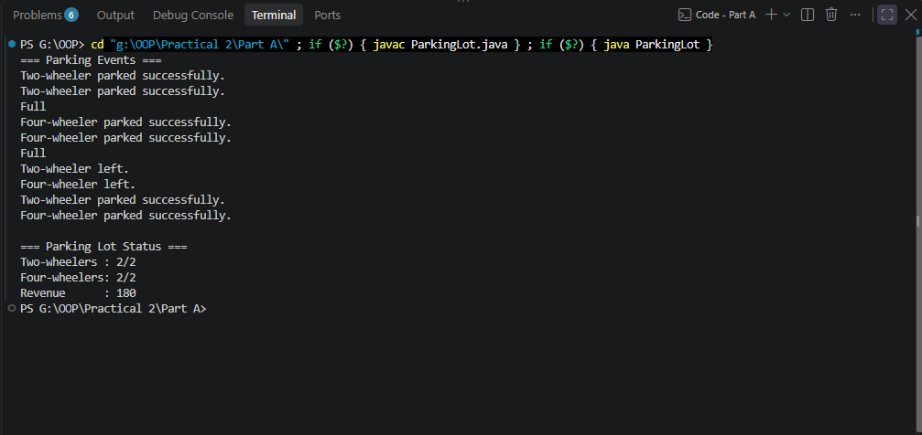

Key Questions / Analysis / Interpretation to be evaluated during/after Implementation
- What is encapsulation, and how do private fields with public getters enforce it?
Ans.
Encapsulation means keeping an object's data protected inside the class and controlling how that data can be accessed or changed.
For example:
private long balance;

public long getBalance() {
return balance;
}
Because balance is private, code outside the Account class cannot directly do:
account.balance = 10000; // ❌ Not allowed
It must use the methods provided by the class:
account.getBalance(); // ✅
account.deposit(1000); // ✅
account.withdraw(500); // ✅
This allows the class to control and validate changes to its data.

- Why is accountNumber declared final?
Ans.
accountNumber is declared:
private final String accountNumber;
because an account number should be assigned once when the account is created and should not change afterward.
For example:
public Account(String ownerName, long openingBalance) {
this.accountNumber = generateAccountNumber();
}
After that, this is not allowed:
accountNumber = "AC9999"; // ❌ Cannot assign a value to final variable
This protects the identity of the account.

- What is the difference between a static field and an instance field when generating ids?

Ans.

Static field
A static field belongs to the class, so there is one shared copy for all objects.
Example:
private static int accountCounter = 1;
If we create three accounts:
Account 1 → AC0001
Account 2 → AC0002
Account 3 → AC0003
The same accountCounter is shared by all three accounts.

Instance field
An instance field belongs to each individual object.
For example:
private String accountNumber;
Every Account object has its own accountNumber.
Account 1 → accountNumber = AC0001
Account 2 → accountNumber = AC0002
Account 3 → accountNumber = AC0003

